EEE 117 Laboratory

Instructor: Sergio Aguilar-Rudametkin

Lab 2: Calculation of Internal Resistance of Voltmeter, Ammeter and Scope

Lab Report by: Angelica Smith-Evans

Lab Session: Friday, 4PM-6:30PM

Due Date of Report: 09/29/2017

Date(s) of Lab: 09/22/2017

Lab Partners: Kaicha Johnson, Rachana Tandel

1. **Introduction:**

In a theoretical analysis of circuits, we idealize each element. The actual analysis usually differs because of the components are not idealized. They have flaws. Quite usually, these flaws manifest in resistance. In an ideal circuit, there is some resistance due to non-idealized wires. This is due to the electrons colliding with the ions in the wire as the electrons move through the wire as a conductor. In metering there is also flaws. These components are not ideal. However, they do have resistance which allows them to measure values such as voltage, as well as current. These components are important to understand in order to build the ideal circuit.

1. **Purpose:**

The purpose of this lab is to become even more familiar with circuit analysis tools, as well as the concepts and ideas of practical analysis. Most specifically, the purpose of this lab is for students to become familiar with learning about internal resistance, as well as learn about the internal resistance of metering devices. This lab will offer students how to approach this problem logically and observe through Kirchoff’s Voltage Law how to measure internal resistance of a component in both series and parallel formations. Another purpose of this lab is to analyze the importance of resistance through metering devices, and why the resistance is either significantly high or significantly low.

1. **Discussion and Results:**

Part 1: The Voltmeter  
Fig.1 and Fig. 2 below illustrate the circuit we built in order to measure the internal resistance of an ammeter. Fig. 1 illustrates the circuit as we would wire it using the multimeter across R1. Fig. 2 is a simplified version of this circuit, where R1 is replaced by Req.

Fig.1) 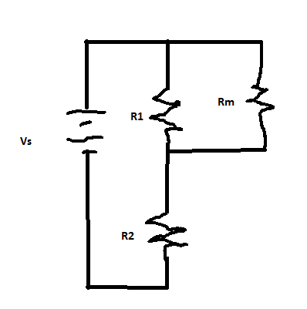  
   
Fig. 2)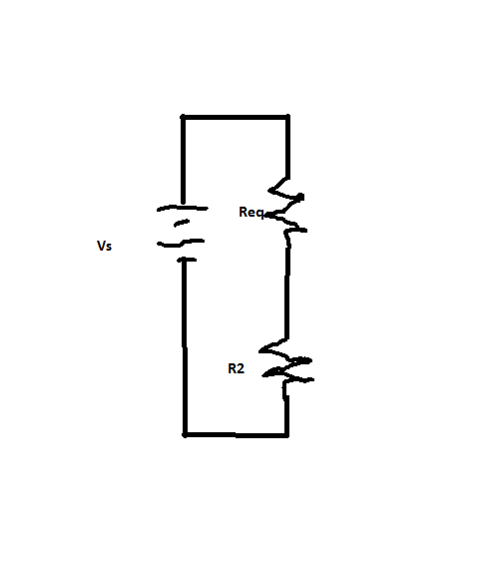

Analysing the circuit above, and by using voltage division, the voltage across Rm can be given by: (eq. 1)Vm= [Req/(Req+R2)]Vs , where Req = R1Rm/(R1+Rm). Running a voltage through this circuit, Vs = 24.01V, the voltage across Rm is read to be approximately 14.93V. Using resistors of R1 = 906.9 kOhm and R2 = 504.95 kOhm, and calculating the internal resistance of the voltmeter using eq. 1, Rm = 10024639.93 Ohm. This is approximately 106 power, or 10 million Ohms. This resistance is extremely high, which means that little to no current will be able to pass through the component. Looking at the second variation of this circuit, where R2 is now in parallel with Rm, shows a similar result.  
Fig. 3)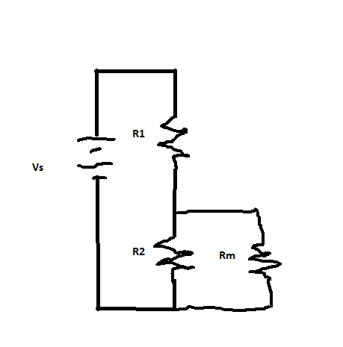Fig. 4)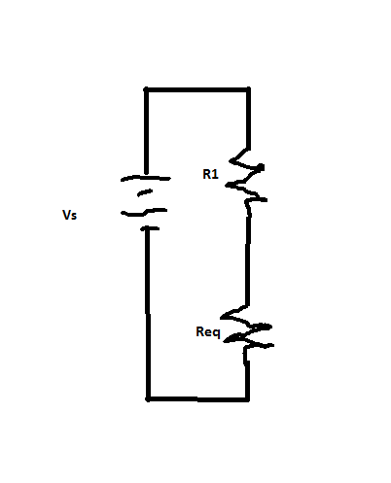

Using eq. 1 to solve find the voltage through Rm, with Vs again given to be 24.01V, and Vm now reading approximately 8.32V, we found the resistance of the voltmeter. Calculating this through with the new reading, we find the resistance to be approximately Rm = 9618962.14V. This is also an extremely high resistance, and in agreement with the first value. This shows that for both configurations, the resistance through the voltmeter is quite high. Calculating the percentage error between these two values yields a 4.05% error, which means that the values agree with each other very well.

Part 2: Oscilloscope

The oscilloscope can be used as a voltmeter as well. Since this is true, then we can import the ideas from the first and second circuit configurations as well as eq. 1 in order to calculate the internal resistance through the oscilloscope. Wiring the circuit like Fig. 1 with a volt source Vs = 24.04V, which results in the voltage across the oscilloscope to be approximately 15V. Plugging this result in eq. 1 along with the same values we used for R1 and R2 yields Vm = 11839003.59V. This is yet again a quite high resistance which is similar to the result in part 1. This is in agreement with the idea that using a voltmeter to observe voltage, there will be a high internal resistance.

Now, in order to confirm this result, we look at the second configuration, which is shown in Fig. 2. Using eq.1 with our new voltage across the voltmeter, Vm = 8.8V, and plugging it in with our resistor values, Rm is calculated to be approximately 27738039.99V. Now once again this is a quite high resistance, however it is significantly higher than the first calculation. Checking our percentage error in this yields a percent error of 57.32%. This percentage error is significantly high. This result could have come about due to an error in some wiring, which I noticed was happening to several other groups within our lab, including ourselves. Another possibility is some error made due to our group rushing to finish the lab within the last 10 minutes of the lab period.

Fig. 5)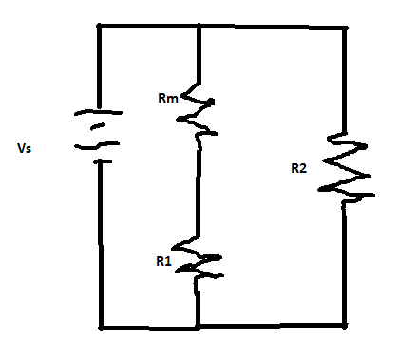Fig. 6)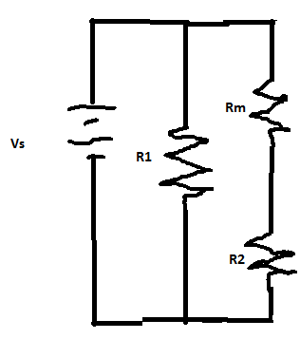

Part 3: The Ammeter

For the final part of analysis of internal resistance is analysis of the ammeter. Looking at Fig. 5 in the first configuration of the circuit shows that the voltage across Rm can be analyzed by the equation: (eq. 2)-Vs+ImRm+ImR1 = o. Plugging in the measured resistance of R1 = 10.24Ohm, and also volt source Vs = -0.2V. The measured current through the component turns out to be Im= 11.946mAmp. Plugging these results in yields an internal resistance of 6.52Ohm. This agrees with the idea that if one is measuring current through a component, then there should be a significantly low resistance through the component in order to not impede the results. Looking at Fig.6 also yields a similar result. Hooking up the circuit in Fig. 6 yields a Im = 7.453mAmp. Using R2 = 20.032Ohm, and plugging into eq.2, yields an internal resistance Rm= 6.788Ohm. This is also in agreement with the preconceived notion that internal resistance should be low through an Ammeter. Comparing these two values brings in a relatively low percentage error of 3.99%. This result is in the range which shows agreement with each other, which helps prove the idea that Ammeter internal resistance should be quite low.

1. **Conclusion:**

In this lab, we were able to analyze resistance through the metering devices provided in the RVR3017 lab: the ammeter, the voltmeter, as well as the oscilloscope. Analyzing the results agrees with the observation that if one is measuring current, the metering device should have a significantly low resistance in order for current to flow properly. As for the oscilloscope and voltmeter, the resistance is significantly high in order for little current to flow through as to not impede the metering of the voltage.

A problem that arose within this lab is the possibility of error using the equipment within the lab. Although we understood very well how to use the equipment, it was very difficult to assess if there errors we were getting throughout the lab was due to personal error, component error, or equipment error. Sometimes, the error felt like a combination of the three. These difficulties often set us back on time by a large degree. Because of this, we rushed through the final portion without regard to error checking. This information however may be helpful to help us students learn that errors in actual analysis may be due to equipment error. To alleviate this problem, it may be best to check along the way with other teams in order to find the errors much quicker.